Documentation &

Project Diary

Innovation Lab 3

Year 2023

Project: Visitor-Counter (the Observer)

Team: Group 29

1. **General Information**

**Project name:** Visitor-Counter (the Observer)

**Supervisor:** Lukas Rohatsch, MSc

Innovation Lab 3, 2023

**Projectteam:**

Varga Lukas, if20b167@technikum-wien.at, project manager

Düx Stefan, if20b245@technikum-wien.at,

Görög Jessica Isabella, if20b094@technikum-wien.at,

Grabner Dominic, if20b219@technikum-wien.at,

Tscheppen Rebekka, if20b164@technikum-wien.at,

**Management Summary of the Project**

This project is about setting up a camera module at the entry of the Presentation Lab to count visitors and deliver data categorized to different data packages (total, daily, current and so forth). To deliver this project, hardware is necessary to be set up correctly (central processing unit, camera, body, holding), combined with efficient software (control the hardware) and a webpage to enable access of the data. Furthermore, this project shall serve as a preparation for more advanced projects like analyzing traffic data, rate of flow and similar purposes.

**Framework Conditions and Project Environment**

*Programming languages:*

The project assignment demands to use python for processing the data. As a commonly used programming language, currently no other programming language is considered for further use regarding data processing. For the webpage the team will use the framework Angular.

*Usability:*

There are 2 access points for the client and / or users. The webpage is enabled for open access which includes all users with access to the internet. Therefore, the usability aims for beginner-level access. The local access directly connected to the visitor counter will be especially designed for the client.

*Interfaces:*

Data transfer by MQTT

*Standards:*

It is necessary to respect the data protection rules as we enable open access to the collected data by our built webpage. Therefore, a livestream of the set up camera will only be accessible at the local console, where the module is located. The webpage will only display the processed data without any pictures or livestreams.

Using own made videos or demo videos to test or logic programming.

*Deadlines:*

Prototype for end of Semester #5

*currently no further details identified*

**Semester-Roadmap**

|  |  |
| --- | --- |
| ****1. semester**** | Focus: Raspberry Pi   1. **1. sprint**   install Raspberry Pi OS and configure packages, install camera module   1. **2. sprint**   ensure requirements (python and required packages)   1. **3. sprint**   expand python libraries   1. **4. sprint**   implement system for visitor counter   1. **5. sprint**   final capture of visitor   1. **6. sprint**   prepare presentation |
| ****2. semester**** | Focus: Raspberry Pi / Interface   1. **7. sprint**   test phase of last streams / buffer for bug fixes   1. **8. sprint**   camera stream over HDMI   1. **9. sprint**   test video capture of visitors on site   1. **10. sprint**   install and configure mgtt   1. **11. sprint**   provide and test interface   1. **12. sprint**   bug fixing  **13. sprint**  prepare presentation |
| ****3. semester**** | Focus: Interface/Website   1. **14. sprint**   plan website and install webserver   1. **15. sprint**   implement website   1. **16. sprint**   finalize website – Raspberry Pi – connection   1. **17. sprint**   bug fixes   1. **18. sprint**   bug fixes   1. **19. sprint**   prepare presentation / end project |

**Collaboration & Tooling**

Communication: Discord & Zoom

[FH Technikum Wien - Moodle](https://moodle.technikum-wien.at/mod/zoom/view.php?id=856605)

Documentation: Jira Software  
[https://visito-counter29.atlassian.net/jira/software/projects/TO29/boards/1](https://visito-counter29.atlassian.net/jira/software/projects/TO29/boards/1" \o "https://visito-counter29.atlassian.net/jira/software/projects/TO29/boards/1)

Timetable: Google Sheets  
https://docs.google.com/spreadsheets/d/1ep5FswrHorSOHT6Ck-h5r6ZSO9rwkWMd2KY0pQrVxrQ/edit#gid=1398090908

Tracking Work: Jira Software

[https://visito-counter29.atlassian.net/jira/software/projects/TO29/boards/1](https://visito-counter29.atlassian.net/jira/software/projects/TO29/boards/1" \o "https://visito-counter29.atlassian.net/jira/software/projects/TO29/boards/1)

Source Code Management: GitHub

[GitHub - unravelet/theObserver: Innovation Lab Project - Visitor Counter](https://github.com/unravelet/theObserver)

Screen Prototyping: Mockplus

No project currently existing

Modelling: Modelio

No project currently existing

**Remarks**

*--*

1. **Brief Description of the Project**

The ****main object**** for the project is a visitor counter which will be located at the “Presentation Lab” room to count the number of visitors. For the counting a camera module will be used in combination with a software to detect and count people from a livestream. This functionality can be used as an example to display or even regulate a maximum number of people inside for health (Covid) or security reasons (events).

As the ****biggest challenge****, the project group will face the needs of learning the necessary skills (logic programming with python) and mechanical capabilities (working with hardware like Raspberry Pi, camera module and 3D printer).

The ****usability object**** will be the easy access to the data and controlling the interfaces at beginner level (local livestream or processed data via webpage).

The ****non-objective**** of the project is involving face recognition and tracking.

As for the ****scope****, the project covers the functionality to process data from a livestream to calculate the number of people (staying inside a room or entering/leaving) and to display it on a local console + webpage with free access. For implementing the software, we need to know about the specifications necessary for the Raspberry Pi and will orientate on similar projects / products. Additionally, we need to learn about video-recognition software to get the necessary skills.

****ORDER model questions:****

****Opportunity**** - Development of visitor counter for room “Presentation Lab” of campus FH Technikum Wien featuring people recognition to count visitors and displaying data via webpage and local livestream.

****Resources**** - Hardware / Webspace / Software (Libraries)

* Raspberry Pi + camera module (sponsored)
* display for local livestream (sponsored)
* host + domain (sponsored)
* python libraries

****Decision Process**** - guaranteed anonymity

****Exact Solution**** - High complexity implies risk of failing the project.

****Relationship**** - Project is happening.

1. **Specification of the Solution**

**Sprint 1**

*****Basic description of sprint #1:*****

For the first sprint, all group members will check the hardware for existing problems or damage and functionality. Fitting software / operating system will be chosen and installed. An official name for the project is going to be set by brainstorming to use it for the GitHub repository and the webpage domain later on. The trello board will be filled up with tasks and an IDE chosen.

*****Time:*****

****start (sprint #1): 12.10.2021, 17:40:00****

****deadline (protocol): 10.11.2021, 23:59:00****

****deadline (sprint #1): 11.11.2021, 16:09:59****

*****Content:*****

****bug fixes [#1reqID]****

* no bugs at start

****software [#1reqID]****

* #1 check installed OS and think about need of alternative OS
* #2 install packages (SSH)
* #3 test camera module by live recording
* #4 choose and set up IDE

****hardware [#1reqID]****

* #5 check quality of all hardware components
* #6 test functionality of all hardware components

****documentation [#1reqID4_]****

* #7 fill trello board with tasks (backlog)
* #8 specify name of project in preparation for GitHub repository + web domain
* #9 add “3D print” as task in semester roadmap
* #10 generate 3D model of PresentationLab for overview
* #11 add pictures to notes
* #12 plan switch to Jira Collaboration Tool

*****Assignment:*****

* Dominic, Jessi + Lukas => documentation (total)
* Stefan + Rebekka => software (total)
* whole team=>hardware (total)

**Sprint 2**

*****Basic description of sprint #2:*****

For the second sprint the group will ensure requirements, try out to use Jira collaboration tool (past sprint has shown potential of difficult information handling by Google Docs and Trello for a project volume of 1,5 years. A repository will be generated + domain name for webpage defined in documentation and the 3D case print for the Raspberry Pi (camera module inclusively) planned.

*****Time:*****

****start (sprint #2): 11.11.2021, 17:40:01****

****deadline (protocol): 24.11.2021, 23:59:00****

****deadline (sprint #2): 25.11.2021, 16:09:59****

*****Content:*****

****bug fixes [#2reqID1_]****

* #1 swap PoE because of malfunctions

****software [#2reqID2_]****

* #2 install chosen IDE
* #3 search for suitable packages / libraries
* #4 install new packages
* #5 test new packages

****hardware [#2reqID3_]****

****documentation [#2reqID4_]****

* #6 update Trello tasks
* #7 create GitHub repository
* #8 upload all documentation and other elements to repository
* #9 determine constant date for weekly sprint meeting
* #10 embed Jira
* #11 3D model case Raspberry Pi planning (+ PoE, + camera module)
* #12 create Milestones for Trello

*****Assignment:*****

* Rebekka (GitHub + Trello tasks, Milestones)
* Dominic + Lukas (3D Planung + Jira)
* Jessica + Stefan (Packages + Libraries)
* Team (IDE, Libraries)

**Sprint 3**

*****Basic description of sprint #3:*****

For the third sprint the group will expand the python libraries, proceed with the planning and realizing of the 3D model case. Furthermore, the change in documentation from Google Docs and Trello to Jira will be realized and every team member uses the sprint to get in touch with the different collaboration tool.

*****Time:*****

****start (sprint #3): 25.11.2021, 17:40:01****

****deadline (protocol): 08.12.2021, 23:59:00****

****deadline (sprint #3): 09.12.2021, 16:09:59****

*****Content:*****

****bug fixes [#3reqID1_]****

* #01 clarify status of replacement for PoE module

****software [#3reqID2_]****

* #02 adapt missing libraries / packages
* #03 test adapted libraries / packages
* #04 tutorium of first steps for rest of team members
* #05 test and use new packages (no hardware necessary for testing with dummy data
* #06 generate test video for dummy data in PresentationLab

****hardware [#3reqID3_]****

* #07 print 3D hardware case

****documentation [#3reqID4_]****

* #08 update Jira tasks
* #09 connect GitHub repository
* #10 continue communication with ProjectKitchen
* #11 start plan and execute printing process for 3D case

*****Assignment:*****

* Jessica + Stefan (02, 03, 04)
* Dominic + Rebekka + Lukas (07, 10, 11)
* Lukas (01)
* Rebekka (08)
* Alle (04, 05, 06, 09)

**Sprint 4**

*****Basic description of sprint #4:*****

For the fourth sprint the group will implement the system for visitor counter, decide and plan next steps for 3D print. First thoughts about final phase of semester will be topic in discussions and planning on what to do for the upcoming sprints regarding the end of semester #3.

*****Time:*****

****start (sprint #4): 09.12.2021, 16:45:01****

****deadline (protocol): 15.12.2021, 23:59:00****

****deadline (sprint #4): 16.12.2021, 16:09:59****

*****Content:*****

****bug fixes [#4reqID1_]****

* #01 library PIL could not be installed

****software [#4reqID2_]****

* #02 use demo videos and generate data from it
* #03 test / use new packages in team

****hardware [#4reqID3_]****

****documentation [#4reqID4_]****

* #04 update Jira tasks
* #05 update GitHub repository
* #06 discuss next steps with supervisor for 3D print
* #07 answer ProjectKitchen about next steps for 3D print
* #08 discussions about what to do in preparation for end of semester #3

*****Assignment:*****

* Team (02, 03, 08)
* Rebekka, Lukas, Dominic (06, 07)
* Rebekka (04)
* Jessica, Stefan (01)

**Sprint 5**

*****Basic description of sprint #5:*****

For the fifth sprint the group will take time to focus on the main functionality of recognizing people from pre-defined videos. Additional software to adapt from computervision.zone will be used and python project added to the repository. An additional version to use person recognition from livestream will be tried to implement. Furthermore a prototype will be generated to use for the final presentation of the semester.

*****Time:*****

****start (sprint #5): 16.12.2021, 16:45:01****

****deadline (protocol): 12.01.2022, 23:59:00****

****deadline (sprint #5): 13.01.2022, 16:09:59****

*****Content:*****

****bug fixes [#5reqID1_]****

* #01 fix problem with current person recognition in terms of speed
* #02 fix problem with current person recognition in terms of recognition

****software [#5reqID2_]****

* #03 adapt software for better recognition
* #04 adapt software for useful display of output (text in video)
* #05 improve software by adding from computervision.zone (gestic recognition etc)

****hardware [#5reqID3_]****

****documentation [#5reqID4_]****

* #06 update Jira tasks
* #07 update GitHub repository
* #08 add python project to repository
* #09 create branches on repository to work with the team
* #10 remind ProjectKitchen of email communication to clarify current status of 3D print

*****Assignment:*****

* Team (03, 04, 05)
* Rebekka (06, 08, 09)
* Lukas und Dominic (10)
* Jessica und Stefan (01, 02)

**Sprint 6**

*****Basic description of sprint #6:*****

The sixth and final sprint for the semester will focus on documentation only. After the documents are summarized to one project diary, a video of the documentation and working python project will be generated and uploaded.

*****Time:*****

****start (sprint #6): 13.01.2022, 16:00:01****

****deadline (protocol): 19.01.2022, 23:59:00****

****deadline (sprint #6): 20.01.2022, 15:14:59****

*****Content:*****

****bug fixes [#6reqID1_]****

* #01 print correct number of people detected
* #02 adapt position of camera for full recognition of software

****software [#6reqID2_]****

****hardware [#6reqID3_]****

****documentation [#6reqID4_]****

* #03 update Jira tasks
* #04 update GitHub repository
* #05 answer ProjectKitchen for 3D print in presence
* #06 generate video for “final” presentation (including documentation + python code)
* #07 edit/sum up documentation for “final” hand-in

****Assignment:****

* Stefan, Jessica, Dominic (#04, #06)
* Rebekka, Lukas (#01, #02, #03, #05, #07)

**Sprint 7**

*****Basic description of sprint #7:*****

The 7th sprint indicates the start of the 4th semester and second semester of time working on the project. For this initial phase the group decided to start working on 2 mockups (prototype) for the user interface, adapt and research for better use of the software regarding scope of person recognition and counting daily or current number of visitors and contacting ProjectKitchen in regards of 3D print.

*****Time:*****

****start (sprint #7): 18.03.2022, 13:35:01****

****deadline (protocol): 29.03.2022, 23:59:00****

****deadline (sprint #7): 01.04.2022, 12:04:59****

*****Content:*****

****bug fixes [#7reqID1_]****

****software [#7reqID2_]****

* #01 browse alternative software to recognize same person inside room (out of scope and back in)?
* #02 discuss with supervisor if necessary to differ between number of daily visitors or current visitors
* #03 adapt software to recognize person with whole body or only torso/etc

****hardware [#7reqID3_]****

****documentation [#7reqID4_]****

* #04 update Jira tasks
* #05 update GitHub repository
* #06 write ProjectKitchen for 3D print in presence
* #07 write mail to Supervisor to confirm date and time of next meeting
* #08 choose fitting software to create mockups
* #09 create 2 mockups to display a user interface for Presentation Lab
* #10 discuss with supervisor of whom to fill in the Businessvalue of T-Shirt sizing at effort estimation sheet

****Assignment:****

* Stefan, Lukas und Jessica (#01, 02, 03)
* Dominic und Rebekka (#08, 09)
* Lukas (#04, 05, 06, 07)

**Sprint 8**

*****Basic description of sprint #8:*****

The 8th sprint sums up our work with finalizing the software for human detection while deciding for the final version and doing some bugfixes. One of the 2 created mockups will be chosen to get a final design (supervisor will give some input for further functionality) and prepared to be used for the implementation and presentation at the end of the current semester. The time effort estimation will be redone with the DAGoPERT sheet and other administration tasks like Jira, GitHub and mail communication on the regular basis. Finally the Raspberry Pi will get the software implemented and connected with the hardware (hdmi cable, camera module) and tested.

*****Time:*****

****start (sprint #8): 01.04.2022, 12:50:01****

****deadline (protocol): 19.04.2022, 23:59:00****

****deadline (sprint #8): 21.04.2022, 12:04:59****

*****Content:*****

****bug fixes [#8reqID1_]****

* #01 new versions of human detection need fixing in orientation of recognizing shapes

****software [#8reqID2_]****

* #02 decide for final version of human detection and present to supervisor at upcoming meeting
* #03 discuss further functionality of user interface for local use of raspberry pi

****hardware [#8reqID3_]****

* #04 implement final software of human detection @raspberry pi 4
* #05 test automatic start of software within start of system
* #06 connect hardware (camera + raspberry pi) and test current software
* #06_2 try NoIR module for Raspberry Pi 4
* #06_3 browse information for alternative camera modules for usage and mail supervisor if needed (necessary adaption)

****documentation [#8reqID4_]****

* #07 update Jira tasks
* #08 update GitHub repository
* #09 contact ProjectKitchen again for appointment of 3D print
* #10 redo time effort estimation via DAGoPERT
* #11 add Tshirt Sizing for time effort estimation in DAGoPERT sheet file
* #12 choose one of the created mockups for user interface @PresentationLab
* #13 finalize mockup for user interface (adapt & finish)
* #14 make appointment with supervisor for upcoming meeting

****Assignment:****

* Dominic, Rebekka (#12, #13)
* Stefan, Jessica, (#01)
* Stefan, Jessica, Lukas (#02, #03)
* Stefan, Jessica, Dominic, Rebekka, Lukas (#04, #05, #06, #10, #11)
* Lukas (#07, #08, #09, #14)

**Sprint 9**

*****Basic description of sprint #9:*****

In the 9th sprint the Raspberry Pi will get the software implemented and connected with the hardware (hdmi cable, camera module) and tested live. Project Kitchen appointment will finally be set and 3d case printed. Possible software problems will be fixed if hardware connection and/or live demo fails.

*****Time:*****

****start (sprint #9): 21.04.2022, 13:45:01****

****deadline (protocol): 03.05.2022, 23:59:00****

****deadline (sprint #9): 03.05.2022, 23:59:00****

*****Content:*****

****bug fixes [#9reqID1_]****

* #01 fix possible problems while connecting to hardware / testing live

****software [#9reqID2_]****

****hardware [#9reqID3_]****

* #02 implement final software of human detection @raspberry pi 4
* #03 test automatic start of software within start of system (linux command anlegen um als property zu verwenden)
* #04 connect hardware (camera + raspberry pi) and test current software
* #05 test setup live

****documentation [#9reqID4_]****

* #06 update Jira tasks
* #07 update GitHub repository
* #08 contact ProjectKitchen again for appointment of 3D print

****Assignment:****

**Sprint 10**

*****Basic description of sprint #10:*****

In the 10th sprint the Raspberry Pi will get adapted in the auto start and the mqtt installed/configured. The appointment for the ProjectKitchen will finally be fixed and the 3D case printed. Additionally, a live demo will happen at the location of the Presentation Lab.

*****Time:*****

****start (sprint #10): 05.05.2022, 16:45:01****

****deadline (protocol): 17.05.2022, 23:59:00****

****deadline (sprint #10): 17.05.2022, 23:59:00****

*****Content:*****

****bug fixes [#10reqID1_]****

* #01 fix possible problems while connecting to hardware / testing live
* #02 fix multithreading on pi
* #03 fix autostart problem

****software [#10reqID2_]****

* #04 install mqtt
* #05 configure mqtt
* #06 fine tuning auto start

****hardware [#10reqID3_]****

* #07 live demo at location

****documentation [#10reqID4_]****

* #08 update Jira tasks
* #09 update GitHub repository
* #10 meet at ProjectKitchen and print case
* #11 fill in DAGoPERT T-Shirt sizing for time effort estimation

****Assignment:****

* Team (#01, 02, 03, 04, 05, 06, 07, 09)
* Rebekka (#02, 08, 09)
* Lukas (#10)

**Sprint 11**

*****Basic description of sprint #11:*****

In the 11th sprint the Raspberry Pi will finally get its autostart and mutlithreading, because the effort was higher than anticipated. Additionally, the already configured mqtt software component will be added to the pi. The appointment for the ProjectKitchen will finally be fixed and the 3D case printed, after another delay. With the implemented interface a live demo with the group will happen.

*****Time:*****

****start (sprint #11): 17.05.2022, 13:15:01****

****deadline (protocol): 31.05.2022, 23:59:00****

****deadline (sprint #11): 31.05.2022, 23:59:00****

*****Content:*****

****bug fixes [#11reqID1_]****

* #01 fix multithreading on pi
* #02 fix autostart problem

****software [#11reqID2_]****

* #03 get mqtt software component to raspberry pi
* #04 fine tuning auto start
* #05 install interface by blueprint
* #06 test interface functionality

****hardware [#11reqID3_]****

* #07 live demo with project group

****documentation [#11reqID4_]****

* #08 update Jira tasks
* #09 update GitHub repository
* #10 meet at ProjectKitchen and print case

****Assignment:****

* Rebekka, Stefan (#01)
* Jessica, Lukas, Dominic (#05, 06)
* Lukas, Jessica (#02, 03, 04)
* Rebekka (#08, 09)
* Lukas (#10)
* Group (#07)

**Sprint 12**

*****Basic description of sprint #12:*****

In the 12th sprint all the missed or not fulfilled tasks from past sprints will be fixed and finally implemented. The appointment for the ProjectKitchen will finally be fixed and the 3D case printed, after another delay. With the implemented interface a live demo with the group will happen.

*****Time:*****

****start (sprint #12): 01.06.2022, 19:45:01****

****deadline (protocol): 14.06.2022, 23:59:00****

****deadline (sprint #12): 14.06.2022, 23:59:00****

*****Content:*****

****bug fixes [#12reqID1_]****

* #01 fix multithreading on pi
* #02 fix autostart problem
* #03 implement interface

****software [#12reqID2_]****

* #04 fine tuning auto start
* #05 test interface functionality

****hardware [#12reqID3_]****

* #06 live demo with project group

****documentation [#12reqID4_]****

* #07 update Jira tasks
* #08 update GitHub repository
* #09 appointment ProjectKitchen

****Assignment:****

**Sprint 13**

*****Basic description of sprint #13:*****

In the 13th sprint it is all about completing the missing parts, creating a video for the necessary content to upload and the regarding documentation too.

*****Time:*****

****start (sprint #13): 15.06.2022, 16:45:01****

****deadline (protocol): 28.06.2022, 23:59:00****

****deadline (sprint #13): 28.06.2022, 23:59:00****

*****Content:*****

****bug fixes [#13reqID1_]****

* #01 implement interface

****software [#13reqID2_]****

* #02 test interface functionality

****hardware [#13reqID3_]****

****documentation [#13reqID4_]****

* #03 update Jira tasks
* #04 update GitHub repository
* #05 3D print
* #06 generate video for semester upload
* #07 prepare / complete documentation for semester upload

****Assignment:****

* Rebekka (#03, #07)
* Jessica, Stefan, Lukas, Dominic (#06)
* Group (#04)

**Sprint 13**

*****Basic description of sprint #13:*****

In the 13th sprint it is all about completing the missing parts, creating a video for the necessary content to upload and the regarding documentation too.

*****Time:*****

****start (sprint #13): 15.06.2022, 16:45:01****

****deadline (protocol): 28.06.2022, 23:59:00****

****deadline (sprint #13): 28.06.2022, 23:59:00****

*****Content:*****

****bug fixes [#13reqID1_]****

* #01 implement interface

****software [#13reqID2_]****

* #02 test interface functionality

****hardware [#13reqID3_]****

****documentation [#13reqID4_]****

* #03 update Jira tasks
* #04 update GitHub repository
* #05 3D print
* #06 generate video for semester upload
* #07 prepare / complete documentation for semester upload

****Assignment:****

* Rebekka (#03, #07)
* Jessica, Stefan, Lukas, Dominic (#06)
* Group (#04)

**Sprint 14/15**

*****Basic description of sprint #14/15:*****

The 14th/15th sprint is used as start into final phase of project. Meanwhile the 14th has been used to define the backlog items and referring effort estimation, we will use the 15th (4.10.2022 - 18.10.2022) to work on the first User Stories of the backlog. Besides making an appointment for printing the 3D case (decided to let it be printed instead of using time to do it ourselves), the software solution has to be changed and the webpage will be started to build.

*****Time:*****

****start (sprint #14/15): 04.10.2022, 23:59:01****

****deadline (protocol): 18.10.2022, 23:59:00****

****deadline (sprint #14/15): 18.10.2022, 23:59:00****

****final meeting (sprint review) not chosen yet.****

*****Content:*****

****1. General Administartive****

* TO29-347 – clean / refactor repository
* TO29-348 – create new branch

****2. Detection-Software****

* TO29-316 - Browse for new/more adequat solution
* TO29-317 - Implementation on Windows system
* TO29-318 - Testing of performance and functionality on Windows system

****3. Hardware****

* TO29-325 - Request 3D print at ProjectKitchen (appointment)
* TO29-326 - Send data to print

****4. Website****

* TO29-386 - research different frameworks
* TO29-377 - Choose Framework
* TO29-387 - setup framework

**Sprint 16**

*****Basic description of sprint #16:*****

The 16th sprint is similar to the last sprint regarding the tasks due to time management troubles (working hours and effort of studies too intense to handle properly). It will be discussed what styling the 3D case will get besides setting up the framework for the webpage and additional tasks as well as deciding for alternative software of person detection, implementing on windows, testing and maybe implementing on raspberry pi.

*****Time:*****

****start (sprint #16): 18.10.2022, 23:59:01****

****deadline (protocol): 18.10.2022, 23:59:00****

****deadline (sprint #16): 08.11.2022, 23:59:00****

****final meeting (sprint review) 09.11.2022 18:00:00****

*****Content:*****

****1. General Administartive****

* TO29-348 – create new branch

****2. Detection-Software****

* TO29-316 - Browse for new/more adequat solution
* TO29-317 - Implementation on Windows system
* TO29-318 - Testing of performance and functionality on Windows system
* TO29-331 - Install flask (python webserver to define routes → sending camera stream to webpage)

****3. Hardware****

* TO29-319 - Reset Raspberry Pi
* TO29-320 - Install all necessary packages / DB
* TO29-321 - Install source code synch application
* TO29-322 - Prepare directory for project + synch current code
* TO29-328 - Pickup printed 3D case

****4. Website****

* TO29-386 - research different frameworks
* TO29-377 - Choose Framework
* TO29-387 - setup framework
* TO29-378 - design interface
* TO29-388 - make interface mockup
* TO29-379 - implement skeleton

****5. Database****

* TO29-332 - Request for database access (Grafana + InfluxDB)
* TO29-333 - Setup data table columns

**Sprint 17**

*****Basic description of sprint #17:*****

The 17th sprint is to continue working on the current tasks regarding the raspberry pi, the webpage and the detection software (testing and final phase of implementation). The raspberry pi is printed and will get coloured in an easy working blueish colour. Also the database will get started to be set up and implemented.

*****Time:*****

****start (sprint #17): 09.11.2022, 23:59:01****

****deadline (protocol): 22.11.2022, 23:59:00****

****deadline (sprint #17): 22.11.2022, 23:59:00****

****final meeting (sprint review) 23.11.2022 18:00:00****

*****Content:*****

****1. Detection-Software****

* TO29-402- implement flask on python script (sending stream picture to FE)
* TO29-371- create new demo video to test functionality
* TO29-318 - Testing of performance and functionality on Windows system

****2. Hardware****

* TO29-403 - Get bill from HTW for 3d print
* TO29-329 - Style printed 3D case (coloring)
* TO29-320 - Install all necessary packages / DB
* TO29-323 - Execute and test (live demo) existing project on Raspberry Pi and test functionality
* TO29-324 - Setup autostart

****3. Website****

* TO29-389 - connect database
* TO29-392 - implement views

****4. Database****

* TO29-333 - Setup datatable columns
* TO29-334 - Implement connection in Python script
* TO29-335 - Synch new implementation to Raspberry Pi

**Sprint 18**

*****Basic description of sprint #18:*****

The 18th sprint is to finish the tasks regarding the raspberry pi and continue with the tasks regarding the webpage and the db. The raspberry pi case is printed and will get coloured in an easy working blueish colour and build together with all the hardware.

*****Time:*****

****start (sprint #18): 22.11.2022, 23:59:01****

****deadline (protocol): 06.12.2022, 23:59:00****

****deadline (sprint #18): 06.12.2022, 23:59:00****

****final meeting (sprint review) no appointment yet assigned.****

*****Content:*****

****1. Hardware****

* TO29-320 - Install all necessary packages / DB
* TO29-323 - Execute and test (live demo) existing project on Raspberry Pi and test functionality
* TO29-324 - Setup autostart
* TO29-330 - Build Raspberry Pi hardware setup

****2. Website****

* TO29-389 - connect database
* TO29-392 - implement views
* TO29-394 - implementing functionality

****3. Database****

* TO29-333 - Setup datatable columns
* TO29-334 - Implement connection in Python script
* TO29-335 - Synch new implementation to Raspberry Pi

**Sprint 19**

*****Basic description of sprint #19:*****

The 19th sprint is to finish the raspberry pi (testing, build) to prepare it for the final local setup. Additionally the datatable is going to be tested and the last settings to finalized. The most work remains regarding the webpage which needs to communicate with the db.

*****Time:*****

****start (sprint #19): 07.12.2022, 23:59:01****

****deadline (protocol): 20.12.2022, 23:59:00****

****deadline (sprint #19): 20.12.2022, 23:59:00****

****final meeting (sprint review) 21.12.2022, 17:00:00.****

*****Content:*****

****1. Hardware****

* TO29-323 - Execute and test (live demo) existing project on Raspberry Pi and test functionality
* TO29-330 - Build Raspberry Pi hardware setup

****2. Website****

* TO29-389 - connect database
* TO29-392 - implement views
* TO29-394 - implementing functionality

****3. Database****

* TO29-336 - Testing
* TO29-411 - Adapt influxDB data handling (other results from time to time)
* TO29-412 - Set influxdb datastream to public access

**Sprint 20**

*****Basic description of sprint #20:*****

The 20th sprint is the last sprint to work on technical things, because the sprint after will be used to finish documenting the whole project and ends with a video, describing the finished project. The webpage has to be finished as well as the local access point. Everything will get tested for the last time and the build-up discussed with the supervisor.

*****Time:*****

****start (sprint #20): 20.12.2022, 23:59:01****

****deadline (protocol): 16.01.2023, 23:59:00****

****deadline (sprint #20): 16.01.2023, 23:59:00****

****final meeting (sprint review) no appointment yet assigned.****

*****Content:*****

****1. Hardware****

* TO29-323 - Execute and test (live demo) existing project on Raspberry Pi and test functionality
* TO29-330 - Build Raspberry Pi hardware setup

****2. Website****

* TO29-392 - implement views
* TO29-394 - implementing functionality
* TO29-393 - admin mode for video
* TO29-395 - testing
* TO29-396 – debugging

****3. Database****

* TO29-336 - Testing

**Sprint 21**

*****Basic description of sprint #21:*****

The final upload consists of the documentation and delivery of hardware.

*****Time:*****

****start (sprint #21): 17.01.2023, 23:59:01****

****deadline (protocol): 31.01.2023, 23:59:00****

****deadline (sprint #21): 31.01.2023, 23:59:00****

*****Content:*****

****1. Upload****

* TO29-340 - Paper
* TO29-343 - Marketing Jingle Video
* TO29-344 - Project Diary
* TO29-352 - Final Presentation Powerpoint

1. **Delivery**

GitHub Repository to include all documentation, source code and other resources: <https://github.com/unravelet/theObserver.git>

1. **Our Project Diary**

**Notizen 07.10.2021**

Folge Termine werden so wie das erste Treffen stattfinden (im Break-Out-Room warten)

Deutsch oder Englisch als Entscheidung für die Dokumentation steht frei zu wählen

Self Study C umsetzen bis zum nächsten Mal (kommenden Dienstag)

Presentation Lab B5.xx (Lifte links) => Ausstellungsraum für Projekte

Projekt Kitchen + 3D Drucker möglicher Zugang für das Projekt (=> Gehäuse für Raspberry Pi + Drucker anfertigen [Planung + Ausdruck])

Datenschutz => keine ganzen Bilder direkt über die Webpage abfangen => nur ausgewertete Daten

(2 verschiedene Anzeigen => lokal der Stream [nicht webpage sondern interne Lösung], über Webpage mit öffentlichem Zugang reine Datenauswertung)

=> webpage soll “schön” für Kundenzugang hergerichtet werden

Dokumentation kann von IT-Projekt aus Semester #2 verwendet werden (timetable + project schedule etc)

bei Sprint Zusammenfassung ähnlich wie Semester #2 + Fehleranalyse (grob) in schriftlicher Form

Montag, 11.10.2021, 14:30 5ter Stock A Gebäude rechts nach den Liften, Durchgang zum kleinen Meeting Raum (nicht Studiengangsassistenz) => Hardware Ausgabe (1 Set für Gruppe)

Exact Solution => Zeitabschätzung wie gewohnt

Namens-Gebung überlegen (Github Rep, Webpage => [name.w3.cs.technikum-wien.at](http://name.w3.cs.technikum-wien.at/" \o "http://name.w3.cs.technikum-wien.at))

Kamera soll am Eingang positioniert werden (Vektoren verfolgen für +/-) oder permanent den ganzen Raum filmen (auf Eingang oder in den Raum ausgerichtet?)

Links:

[Search Thingiverse - Thingiverse](https://www.thingiverse.com/search?q=raspberry&type=things&sort=relevant)

zur Verwendung in ProjectKitchen: PrusaSlicer (Aufteilung von Masse und Materialnutzung) => .gcode (File Extension) => auf die SD Karte (beim Drucker vorhanden) spielen und für den 3D Drucker verwenden

office@htw.wien + project kitchen adresse  wegen Schritte für 3D Druck ansprechen (Hochschulvertretung FH) => office@htw.wien ins CC setzen, project kitchen priorisieren

**Notizen 08.10.2021**

* Entscheidung für Positionierung => sollte in den Raum blicken für ständige Zählung durch geplanten 2ten Eingang
* Management-Survey Text ausbessern für die Positionierung der Kamera
* Donnerstag, 14.10.2021, B5.xx Presentation Lab Begehung 10:30/35
* Ende Semester 4 muss Live Demo + Video (5 min) gemacht werden mit Aussicht über noch ausstehende Aufgaben
* Ende Semester 5 Werbevideo mit voll funktionsfähigem Produkt anbieten
* Grafana / InfluxDB / noteRed => zur Verwendung für Webpage (googlen)

**Notizen 14.10.2021**

* Begehung von Presentation Lab (Raum für die Durchführung des Visitor Counter)
* *es wurde bestätigt, dass wir als Entwicklungsteam KEINE Zugangsrechte zum Raum*
* *bekommen => nur durch das Beisein von Supervisor möglich*
* 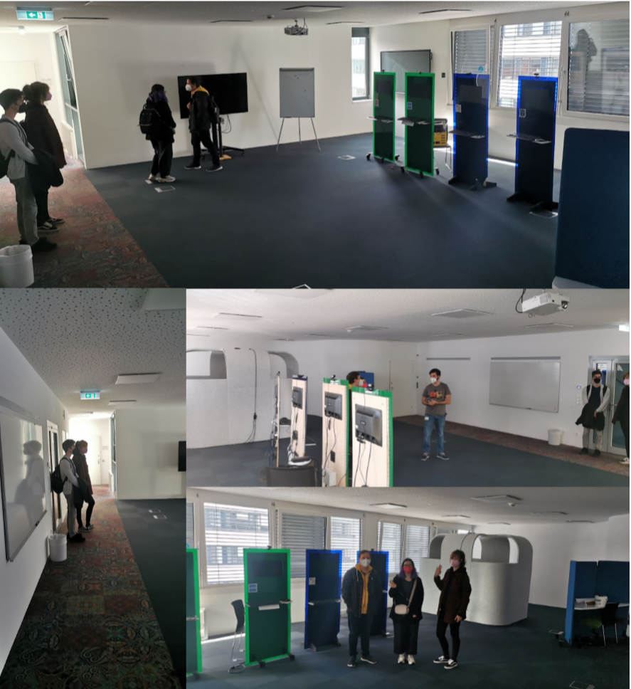Maße des Raums genommen (9x20 Meter)

**Notizen 03.11.2021**

* gemeinsames Meeting (Hardware wurde kontrolliert auf Funktionalität + Beschaffenheit)
* erstmalige Nutzung von Raspberry Pi 4 durch Stromkabel ergab volle Funktionsfähigkeit
* erstmalige Nutzung durch PoE (Power over Ethernet) musste abgebrochen werden aufgrund von Brandgefahr => genauere Verwendung wird in Dokumentation nachgelesen und bei erneuter Brandgefahr wird Supervisor wegen fehlerhafter Funktionalität kontaktiert
* restliche Aufgaben von Sprint #1 wurden verteilt (siehe Abschnitt Sprint#1)
* erste Ausgabe des Livestreams des Pis über HDMI mittels den Befehl raspivid -t 10000

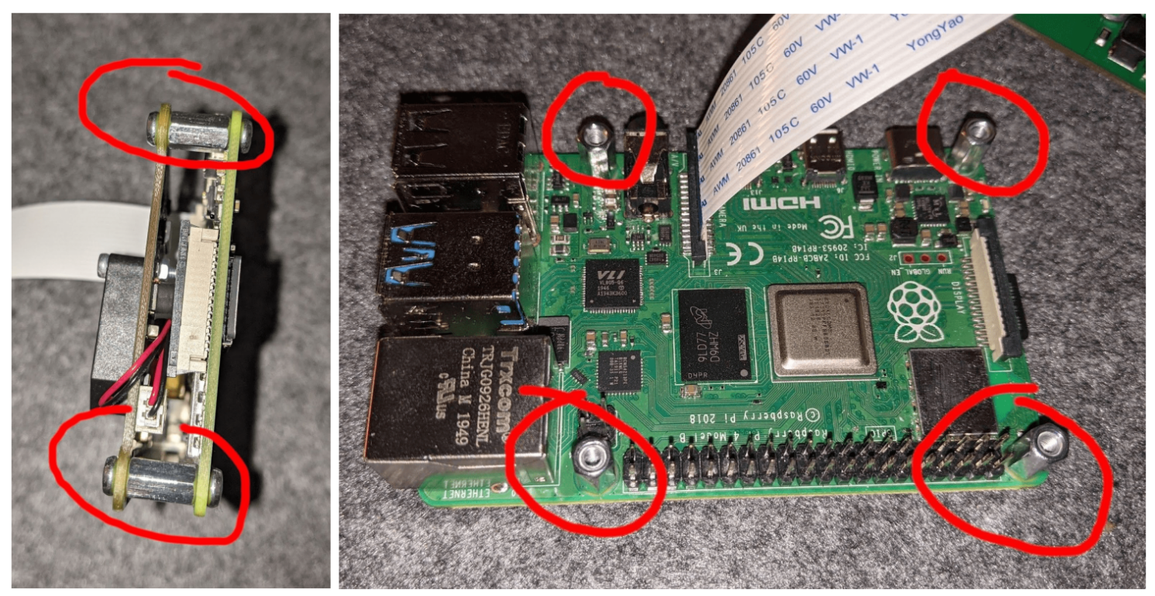

weitere Erkenntnisse im Laufe des Abends (Dominic):

* nach ausführlicher Recherche und genauer Installation (mittels beigefügten Spacers, siehe Foto) funktioniert der PoE Hat weiterhin nicht, vermutlich war dieser bereits bei Auslieferung defekt
* weitere Überlegung bevor die Semester Roadmap adaptiert wird und die Trello Tasks gepflegt werden:

Sollten wir, da sich dieses Projekt über mehrere Semester streckt, eine Art Trello Guideline erstellen, wie die Tasks bei der Erstellung auszusehen hat sowie Handhabung der Tasks?

****Erstellung der Tasks****

z.B. Tags wie “Sprint 1.2”, erstes 1 für erstes Projektsemester, 2 für den zweiten Sprint des Semesters, dadurch könnten wir dynamische Listen erstellen, Task wie “Bug”, “Feature” etc.

****Handhabung der Taks****

z.B. Gegencheck eines anderen Projektmitglieds bevor der Task unter Done abgelegt wird

* zusätzlich sollten wir das Case für den Raspberry Pi (Achtung auf die Kompatibilität des Kamera Moduls sowie dem PoE hat) bereits in den ersten zwei Sprints mit einplanen, da Transport sowie Lagerung (Staub) schädlich für den Raspberry Pi sein könnte

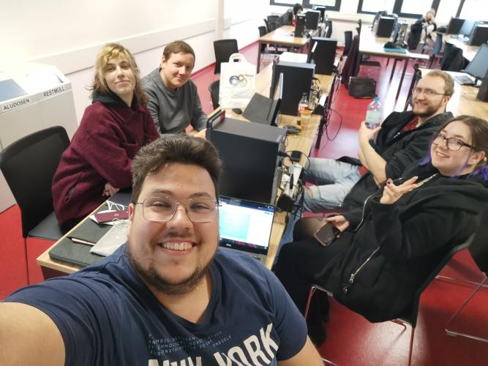

**Notizen 09.11.2021**

Erstellung eines 3D Modells vom “PresentationLab” zur späteren Orientierung und weiteren Handhabung.

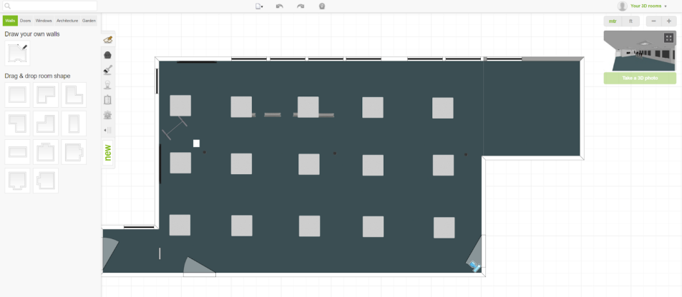

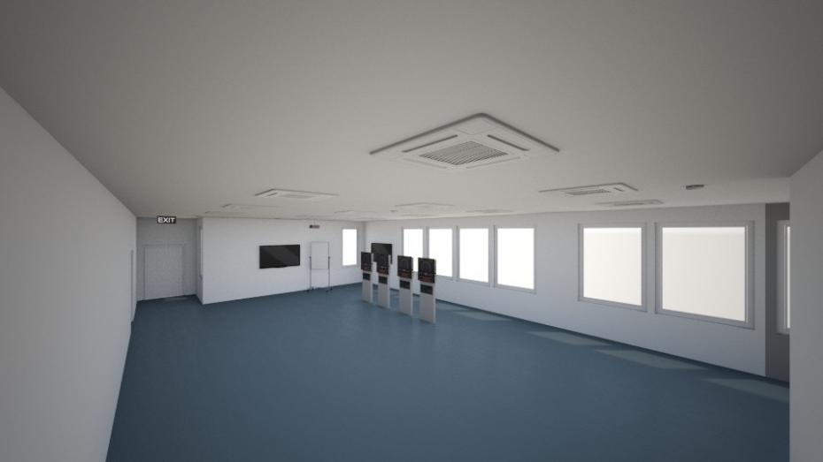

**Notizen 10.11.2021**

Namensvorschläge (Domain / GitHub Repository)

|  |  |
| --- | --- |
| **GitHub** | **Domain** |
| visitorCounter | www.visitorCounter.at |
| studentStalker | www.studentStalker.at |
| mysticEye | www.mysticEye.at |
| **theObserver** | **theObserver.w3.cs.technikum-wien.at** |
| secretEye | www.secretEye.at |
| studentCounter | www.studentCounter.at |
| TW-studentCounter | www.TW-studentCounter.at |

**Notizen 24.11.2021**

Check filaments for 3D print:

* ABS - ****Acrylnitril-Butadien-Styrol**** (2nd most popular filament; Terpolymer => Polymer consisting of 3 different Monomers; popular in the 1950’s; easy handling; tough & heat resistent)
* ASA - ****Acryl-Styrol-Acrylnitrit**** (high quality, but less usable & tough in comparison to ABS)
* PLA - ****Polylactid Acid**** (renewable resources (corn), biodegradable, easy to use for printing, might melt by heat)
* PETG - ****Polyethylenterephthalat**** (recyclable, not biodegradable (contains oil), heat resistent)

**Notizen 25.11.2021**

Meeting with Supervisor:

[https://towardsdatascience.com/how-to-detect-objects-in-real-time-using-opencv-and-python-c1ba0c2c69c0](https://towardsdatascience.com/how-to-detect-objects-in-real-time-using-opencv-and-python-c1ba0c2c69c0" \o "https://towardsdatascience.com/how-to-detect-objects-in-real-time-using-opencv-and-python-c1ba0c2c69c0)

(link for further information of using recognizing software)

Infill

75-80% would be optimal for a resistent use of raspberry pi case

Filament - ABS

we are allowed to do the printing by our own

**Notizen 06.12.2021**

*Configure OpenCV on Raspberry Pi*

First make sure your Pi is using the full SD card

*$sudo raspi-config*

-choose “**Advanced Options**”

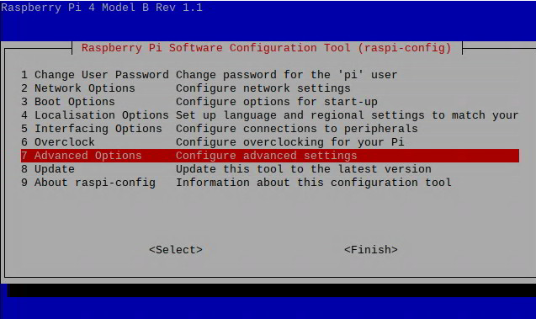

-choose ****"Expand Filesystem"****

****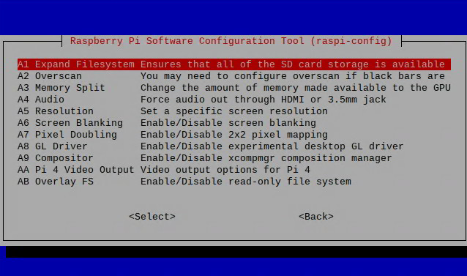****

**Reboot the machine**

***$sudo reboot***

**Check space**

***$df -h***

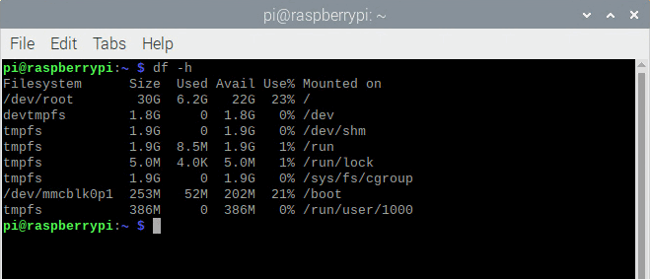

**Update the system**

***$sudo apt-get update && sudo apt-get upgrade***

**Get Pip and **Install OpenCV****

***$mkdir ~/src && cd ~/src***

***$wget https://bootstrap.pypa.io/get-pip.py***

***$ sudo python3 get-pip.py***

**There are two ways to install OpenCV. It is possible to install it for the whole system or use a Python Virtual Environment (which is more recommended)**

1. ****Install OpenCV for the Whole System****

***#$pip install --upgrade pip setuptools wheel***

***sudo pip install opencv-contrib-python***

1. ****Install OpenCV in a Python Virtual Environment****

**Install the **venv** module for Python virtual environments - this need to be done only once for all future projects**

***sudo apt-get install python3-venv***

**Create a new Python project in a virtual environment**

***cd ~ python3 -m venv test***

**This will create a new folder called **test** that you should change to**

***cd ~/test***

**List the folder contents - you should see a file called **pyvenv.cfg****

***cat pyvenv.cfg***

**You should see a result like this (though your version my vary):**

***test= /usr/bin***

***include-system-site-packages = false***

***version = 3.7.3***

***The* ***include-system-site-packages = false*** *line indicates that this program will not use any external packages installed elswhere on your system. The idea is to create a program in an isolated environment. That way it can be run on other systems without having to worry about external dependencies.***

**Switch to the **test** folder and activate the virtual enviromnent**

***cd ~/hello source bin/activate***

**Your prompt should change to something like this (your user and hostname may be different)**

***(test) pi@pi4:~/test $***

**Install OpenCV**

***pip install --upgrade pip setuptools wheel***

***pip install opencv-python***

**Create a new Python file called main.py**

***touch main.py***

**Edit the file using the nano editor:**

***nano main.py***

**Paste some text there and save the file**

***import sys***

***import cv2***

***print("Hello World")***

**From within the virtual environment, run this**

***python main.py***

**You should get a response like this:**

****Hello World****

**You know everything worked fine if you dont have an **error message** that cv2 coudnt be found or something else related to import cv2.**

**In order to deactivate the virtual environment and return to the main operating system command line**

***deactivate***

**Remove a Python virtual environment**

***cd ~***

***rm -rf test***

**Sources**

<https://www.jeremymorgan.com/tutorials/raspberry-pi/how-to-install-opencv-raspberry-pi/>

<https://desertbot.io/blog/raspberry-pi-headless-python-venv-setup>

**Notizen 08.12.2021**

discussion about current topics:

* fill in current sprint review protocoll (review#3)
* don’t forget meta data
* are there tasks not done in the current sprint?
* requirements next sprint?
* semester roadmap says “implement system for visitor counter” what is exactly meant?
* common administration tasks
* communication with ProjectKitchen
* next steps regarding 3D print
* discuss with team if print will be done together in January or contact person does without any of us by himself in the next days due to construction inside ProjectKitchen
* next usage of opencv (regarding videos)
* <https://www.tensorscience.com/object-recognition/person-detection-in-video-streams-using-python-opencv-and-deep-learning> Person detection in video streams using Python, OpenCV and deep learning
* <https://data-flair.training/blogs/python-project-real-time-human-detection-counting/>
* <https://www.youtube.com/watch?v=oXlwWbU8l2o> OpenCV Course - Full Tutorial with Python
* <https://www.computervision.zone/projects/> (Tipp Supervisor)

**Notizen 10.12.2021**

Where to find the ProjectKitchen

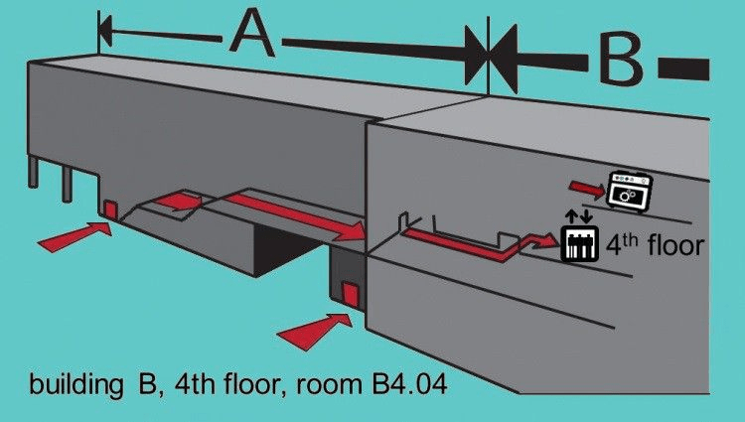

**Notizen 18.01.2022**

mqtt send and recieve counter number

install dependencies for our python project

python.exe -m pip install opencv-python imutils paho-mqtt

then extend code with mqtt functionality and connect with another client and subscribe the topic and see the messages

Password for the Test Topic on HiveMQ is Zuckerwatte3

Client to test Topic: [https://websocketclient.hivemq.cloud/?username=theObserver&host=4ac0ff29055441c8bbfa3caf55826e16.s1.eu.hivemq.cloud&port=8884](https://websocketclient.hivemq.cloud/?username=theObserver&host=4ac0ff29055441c8bbfa3caf55826e16.s1.eu.hivemq.cloud&port=8884" \o "https://websocketclient.hivemq.cloud/?username=theObserver&host=4ac0ff29055441c8bbfa3caf55826e16.s1.eu.hivemq.cloud&port=8884)

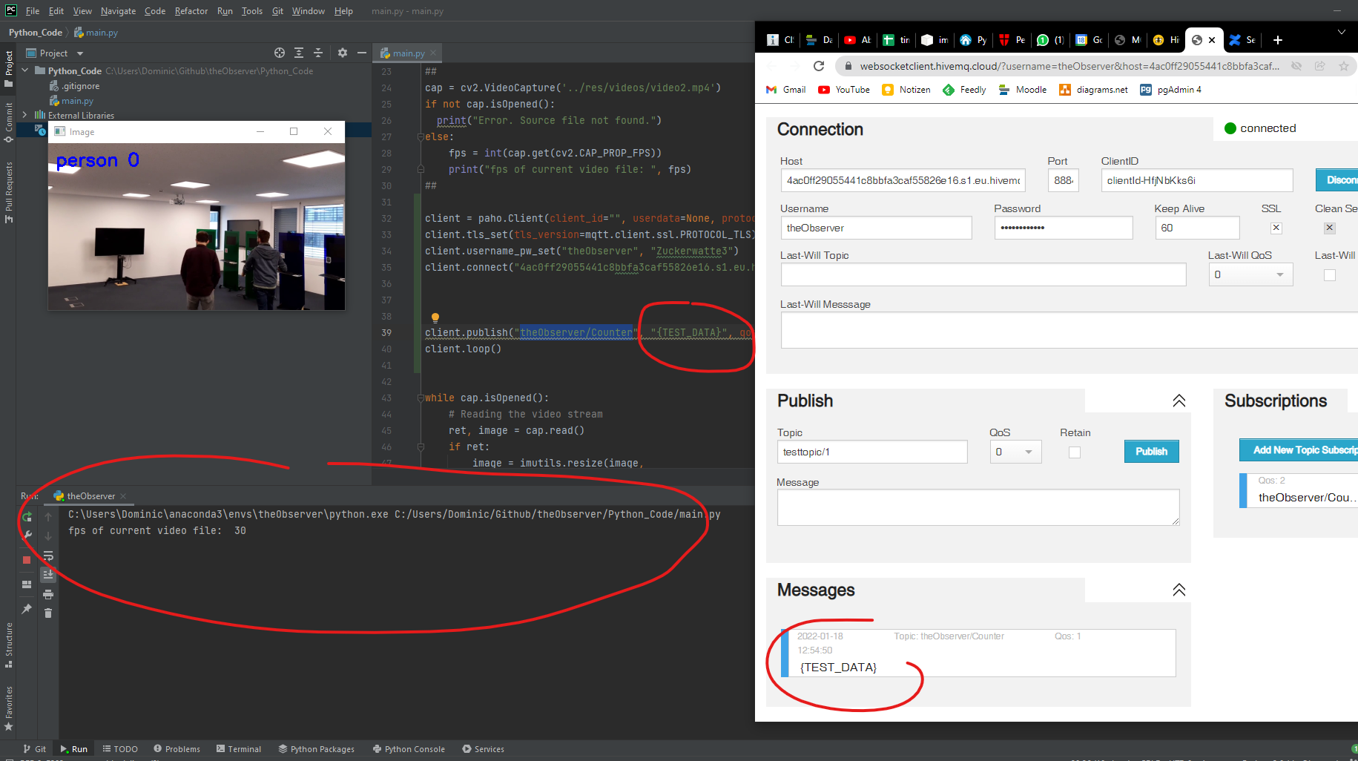

Source for python code: [https://console.hivemq.cloud/clients/python-paho?uuid=4ac0ff29055441c8bbfa3caf55826e16](https://console.hivemq.cloud/clients/python-paho?uuid=4ac0ff29055441c8bbfa3caf55826e16" \o "https://console.hivemq.cloud/clients/python-paho?uuid=4ac0ff29055441c8bbfa3caf55826e16)

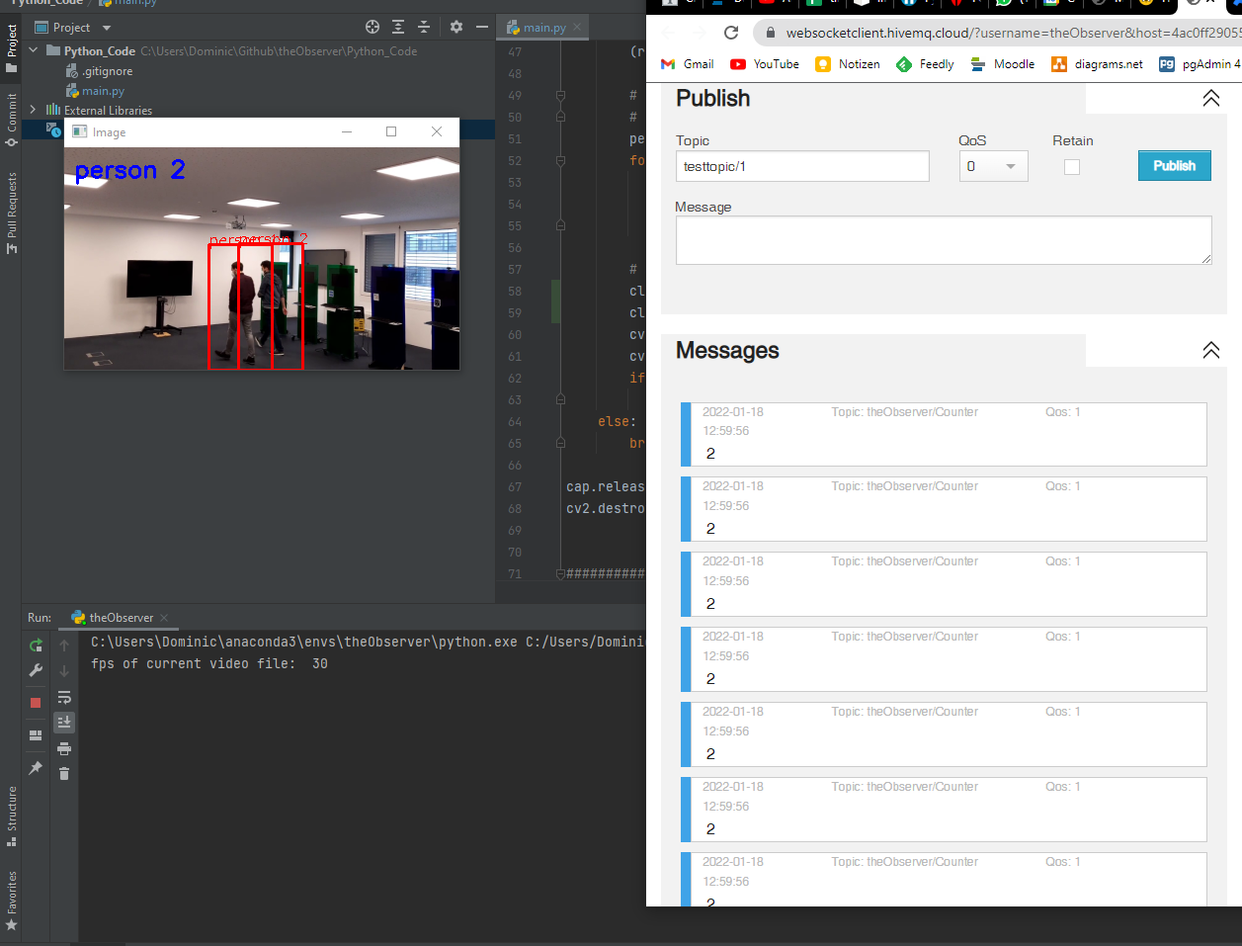

With current code, the counter is send to the topic every frame, but we have to manage the time, otherwise the broker server of mqtt will overflow… maybe just when the number has changed

There is also a mqtt Library for Javascript, see here [https://console.hivemq.cloud/clients/mqtt-js?uuid=4ac0ff29055441c8bbfa3caf55826e16](https://console.hivemq.cloud/clients/mqtt-js?uuid=4ac0ff29055441c8bbfa3caf55826e16" \o "https://console.hivemq.cloud/clients/mqtt-js?uuid=4ac0ff29055441c8bbfa3caf55826e16)

So we don’t really need PHP for our website

Maybe we should consider to set up our own Broker Server on the Raspberry Pi

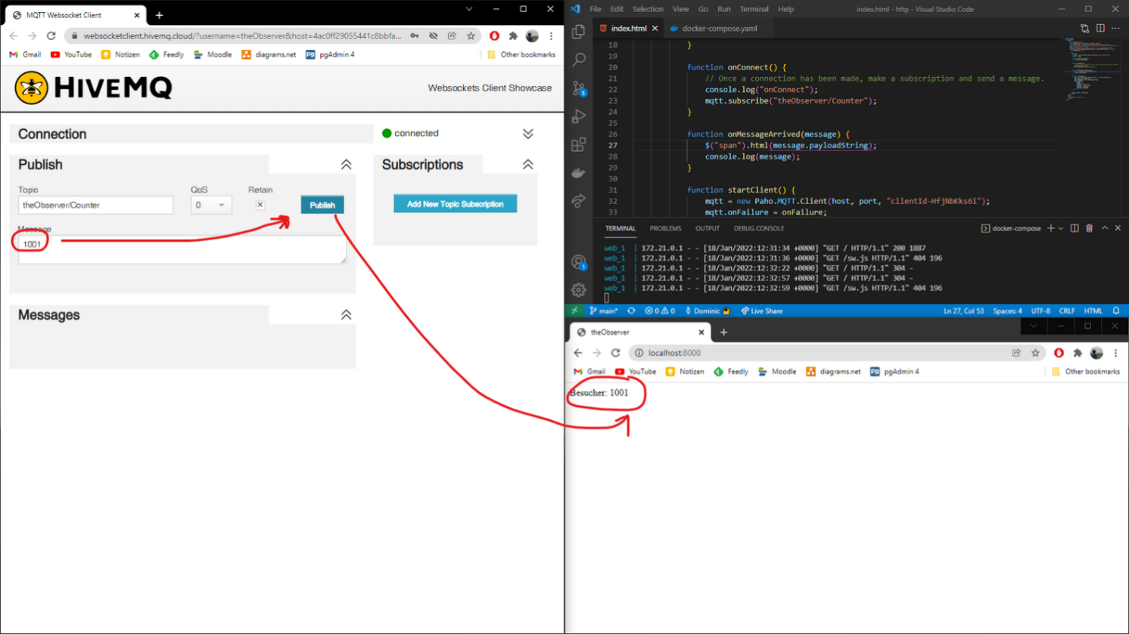

Success test script for html/javascript in git repo in http folder is saved

**Notizen 20.01.2022**

für mqtt folgenden Link nutzen (weitere Informationen researchen):

https://mosquitto.org/

* öffentlichen Broker nutzen (da auch die Webpage öffentlich erreichbar werden soll)

Publisher und Subscriber laufen lassen => achte auf unterschiedliche UID

zuerst mit Broker über URL verbinden (client.connect(url, port, xy))

**Notizen 25.03.2022**

Notes of research regarding people detection/recognition of different scopes:

[explanation of detection vs tracking]

<https://pyimagesearch.com/2018/08/13/opencv-people-counter/>

[detect upper part of body and face]

<https://www.youtube.com/watch?v=x70ALxNzKto>

[detecting by head]

<https://www.youtube.com/watch?v=d1bky80NXeQ>

[count head]

<https://mateoatwi.com/headcount/>

**Notizen 29.03.2022**

theObserver UI Mockups

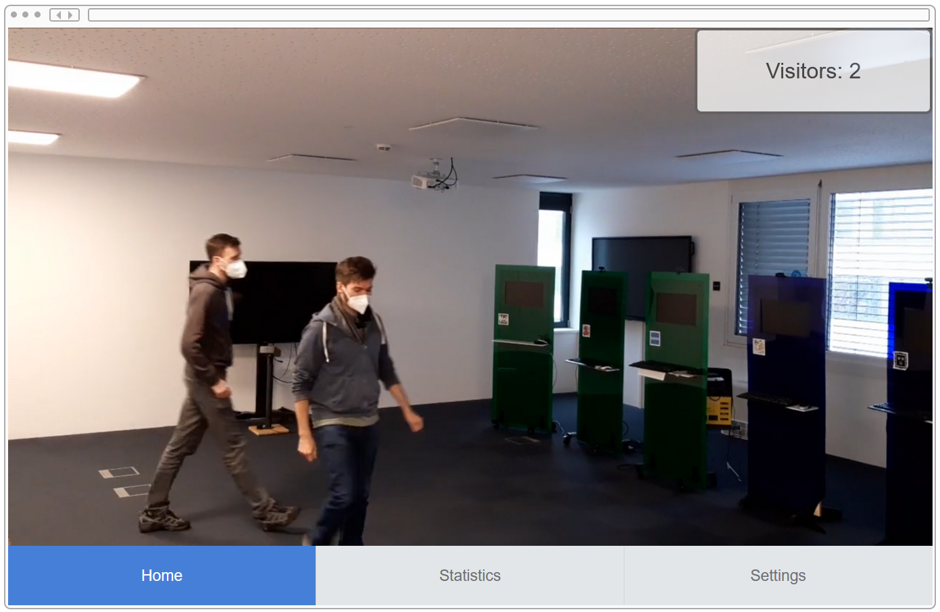

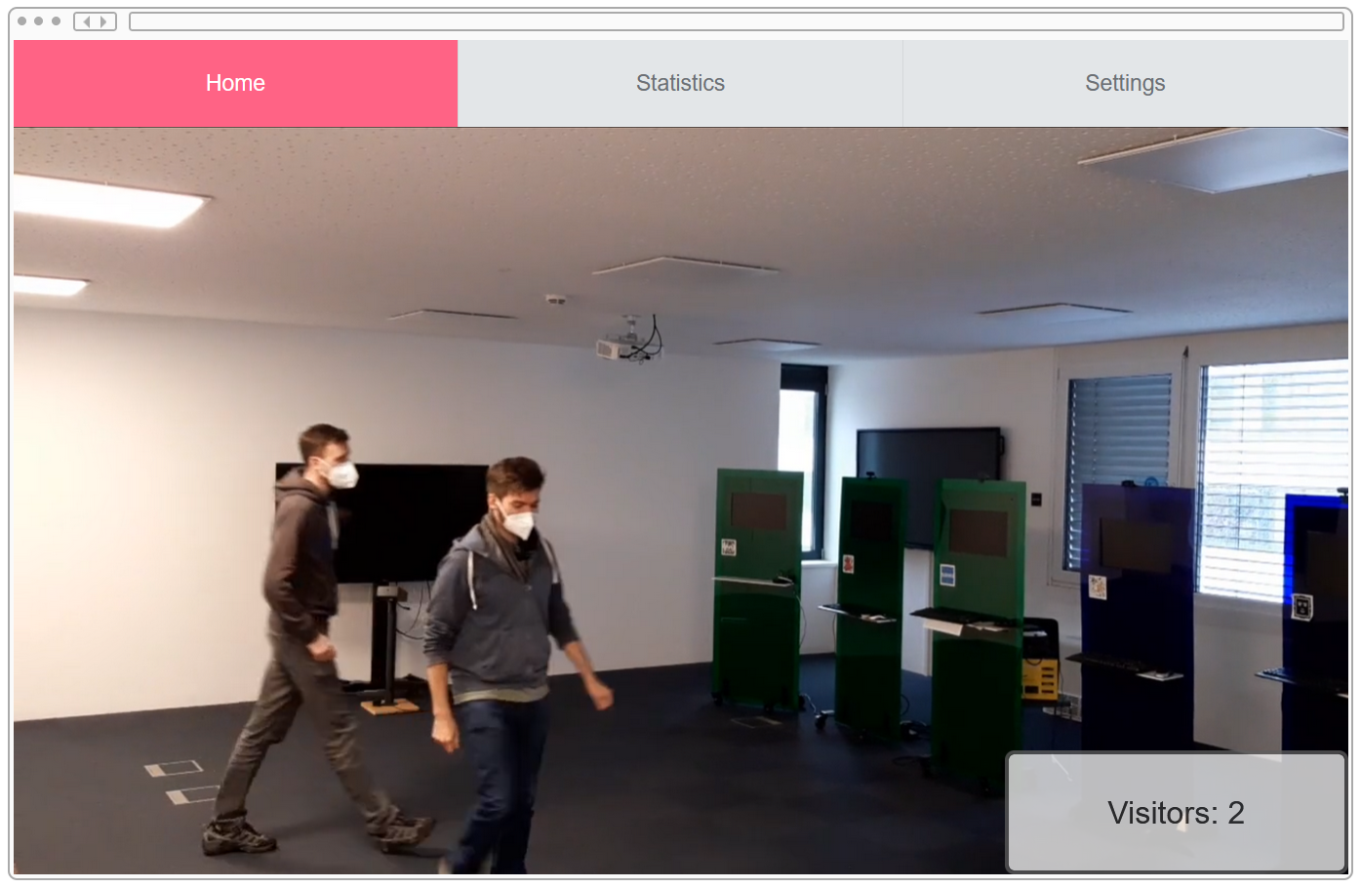

**Notizen 05.05.2022**

I removed the idea folder in the Python_Code folder, because it contains information about the interpreter, which is different on every our computers… so you have to copy it first, before you pull the newest changes, otherwise it will be deleted

also I strongly recommend to use pipenv instead of normal pip and normal python usage

its better for hanelding dependencies in a collaboration environment like ours (greate guid: <https://realpython.com/pipenv-guide/>)

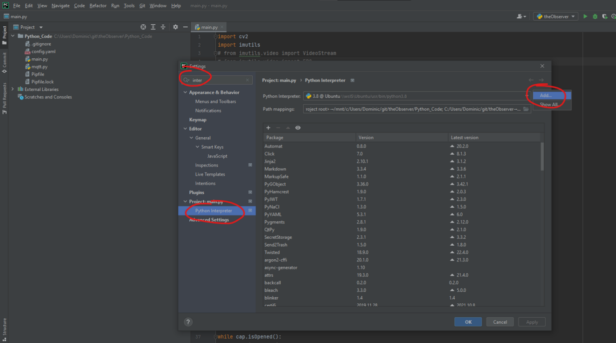

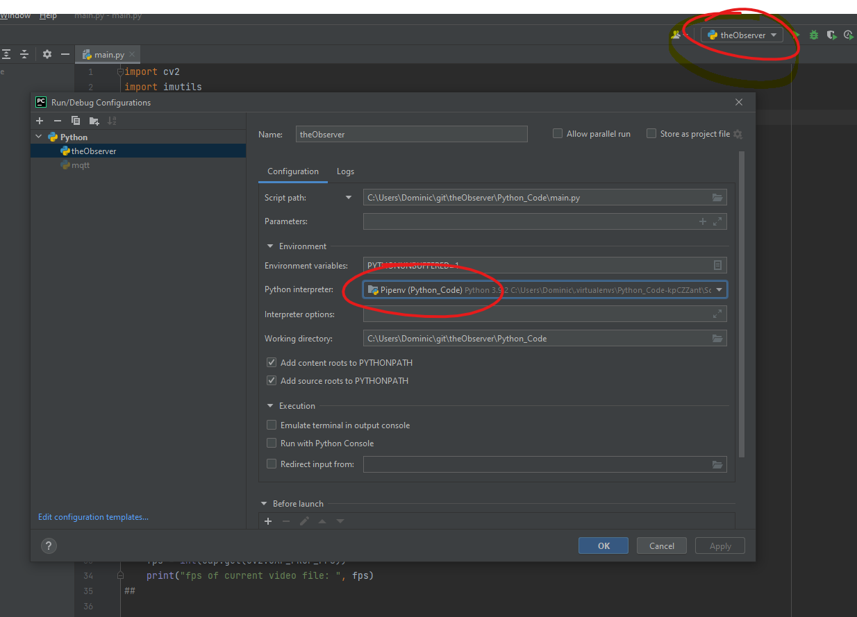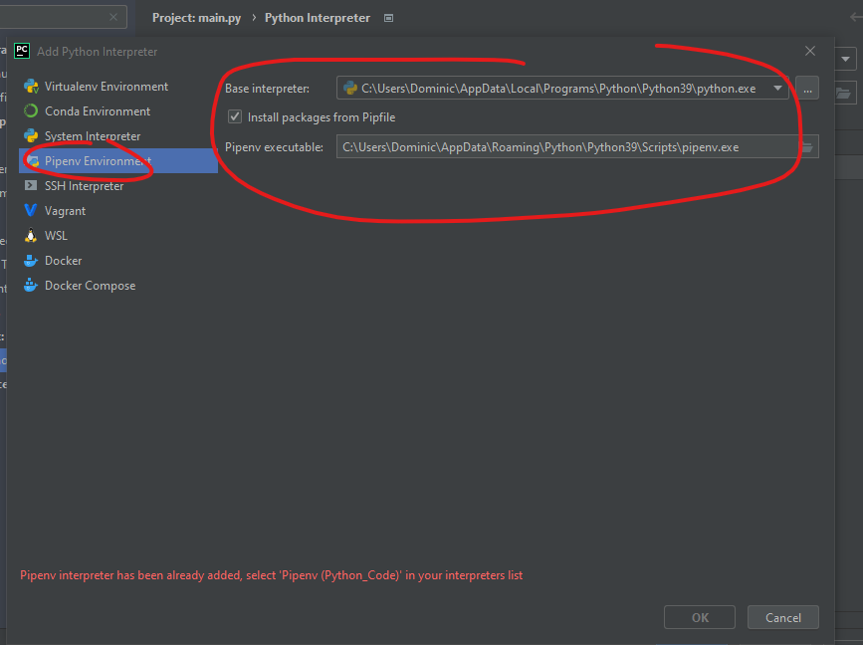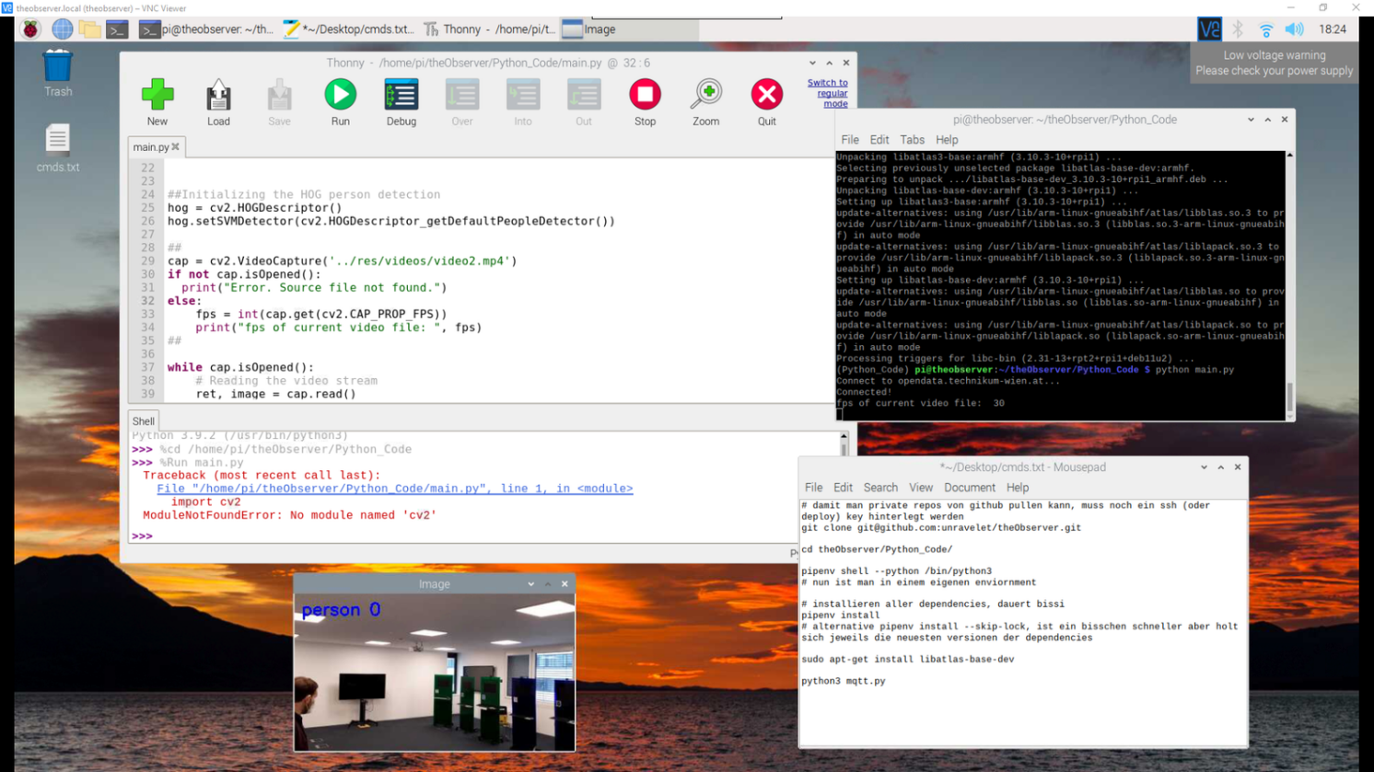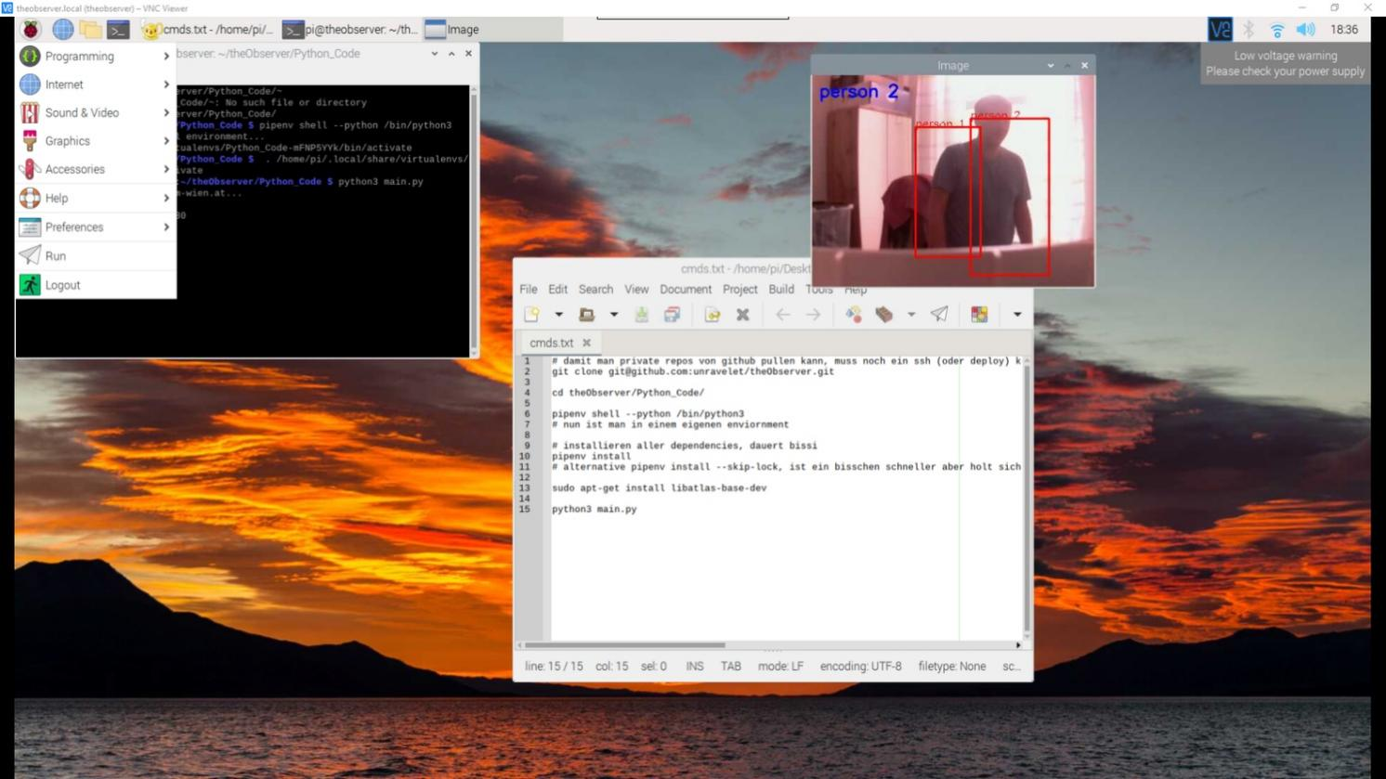

# damit man private repos von github clonen kann, muss man einen ssh key (oder noch besser, deploy key) hinterlegen

git clone git@github.com:unravelet/theObserver.git

cd theObserver/Python_Code/

pipenv shell --python /bin/python3

# nun ist man in einem eigenen enviornment

# installieren aller dependencies, dauert bissi

pipenv install

# alternativ pipenv install --skip-lock, ist ein bisschen schneller, holt aber sich jeweils die neuesten versionen der packages

sudo apt-get install libatlas-base-dev

python3 main.py

python3 mqtt.py

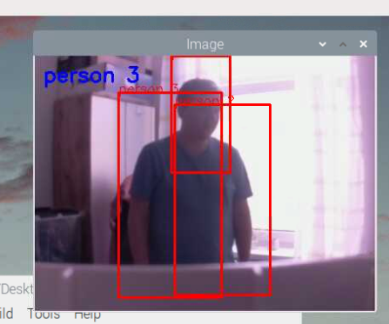

seems like our program thinks I’m big as 3 people

**Notizen 11.05.2022**

<https://www.dexterindustries.com/howto/run-a-program-on-your-raspberry-pi-at-startup/#local>

<https://stackoverflow.com/questions/36466500/on-raspberry-pi-auto-start-terminal-after-login>

<https://forum-raspberrypi.de/forum/thread/3345-autostart-eines-python-script/>

[https://www.digikey.at/en/maker/blogs/2019/running-python-programs-on-startup-using-the-raspberry-pi](https://www.digikey.at/en/maker/blogs/2019/running-python-programs-on-startup-using-the-raspberry-pi" \o "https://www.digikey.at/en/maker/blogs/2019/running-python-programs-on-startup-using-the-raspberry-pi)

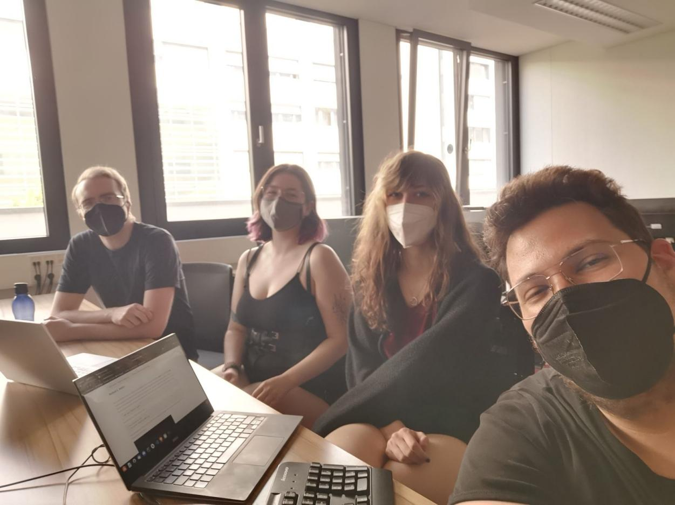

**Notizen 30.09.2022**

Questions supervisor meeting #1

Paper: what is necessary / mandatory? (what can be ignored?)

Appointment supervisor:

Thursday, 06.10.2022 (16:10 - 16:55)

Friday, 07.10.2022 (14:30 - 15:15)

**Notizen 03.10.2022**

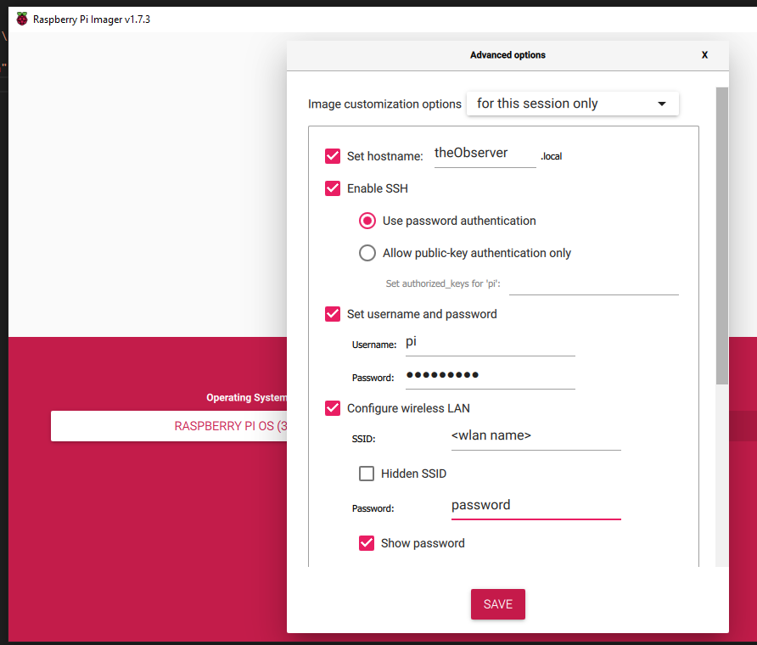

printf " ----- apt-get update -----\n"

sudo apt-get update

printf "\n ----- apt-get upgrade -----\n"

sudo apt-get upgrade -y

printf "\n ----- apt-get dist-upgrade -----\n"

sudo apt-get dist-upgrade -y

printf "\n ----- apt-get autoremove -----\n"

sudo apt-get autoremove -y

git clone https://github.com/unravelet/theObserver.git

git clone https://github.com/djmv/MobilNet_SSD_opencv.git

curl -sSL https://install.python-poetry.org | python3 -

pip install opencv-python imutils requests

pip install -U numpy

sudo apt-get install libcblas-dev libhdf5-dev libhdf5-serial-dev libatlas-base-dev libjasper-dev libqtgui4 libqt4-test -y

**Notizen 25.10.2022 (DB Specifications**

I have just created an instance of our "GIN stack" for you (Grafana, Influx, Node-RED):

<https://nodered-visitor-counter.apps.okd.cs.technikum-wien.at/>

<https://influxdb-visitor-counter.apps.okd.cs.technikum-wien.at/signin>

<https://grafana-visitor-counter.apps.okd.cs.technikum-wien.at/?orgId=1>

For test purposes, I have just made some settings and made a few entries in the database. There are therefore currently two measurements: "sensordata" and "twovals":

Influx UI:

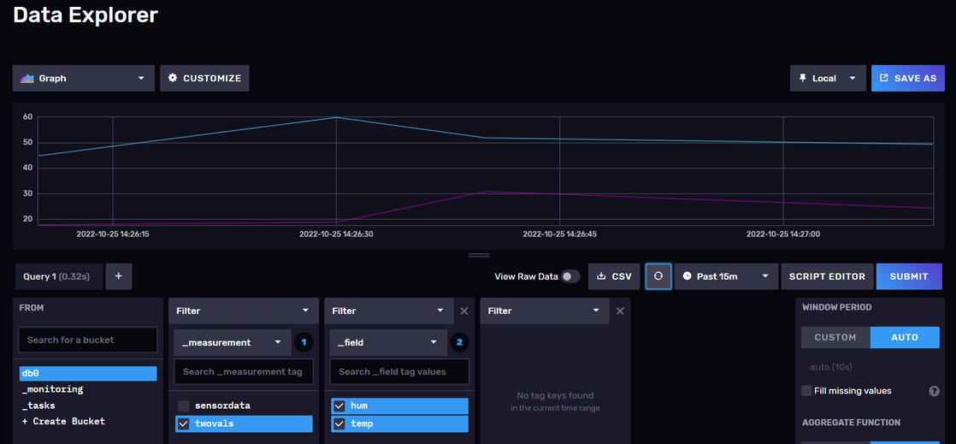

Grafana:

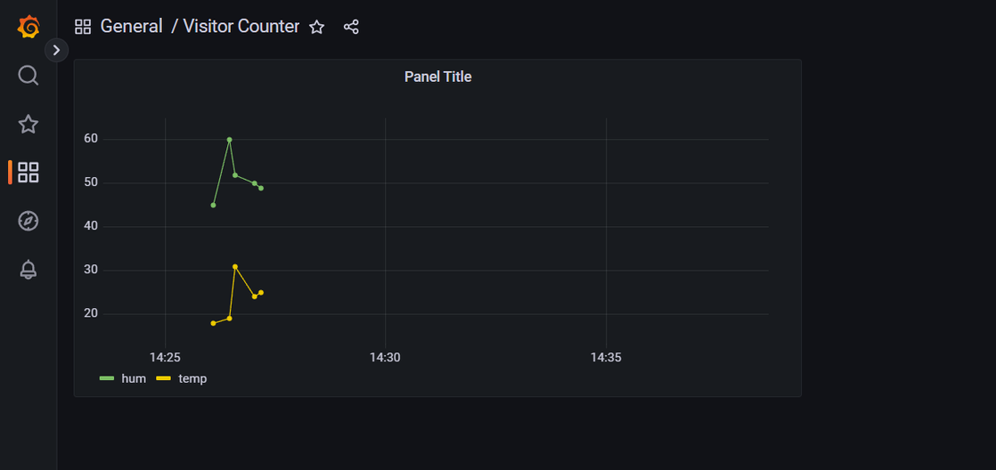

The flows to write data to the database are in Node-RED:

In the following order:

1. Inject – function: generate random value – write it to database on measurement “sensordata”
2. Inject – read data from database (from measurement “sensordata”) – output it to debug-Section
3. Inject – function: generate two random values – write them to database on measurement “twovals”
4. Inject – read data from database (from measurement “twovals”) – output it to debug-Section

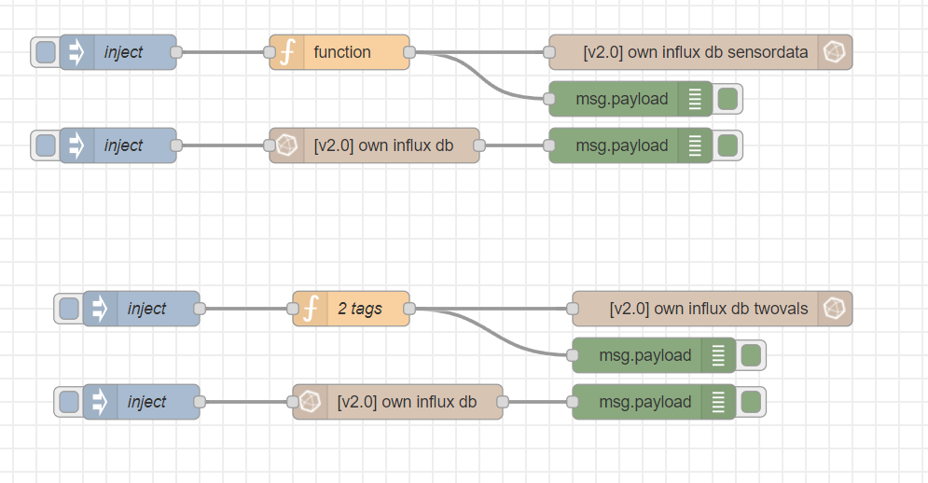

Debug-Section

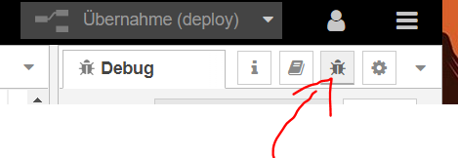

To create a new "Measurement", simply double-click on the node with the arrow and enter a different name for the measurement. The first value in a measurement creates the corresponding "table".

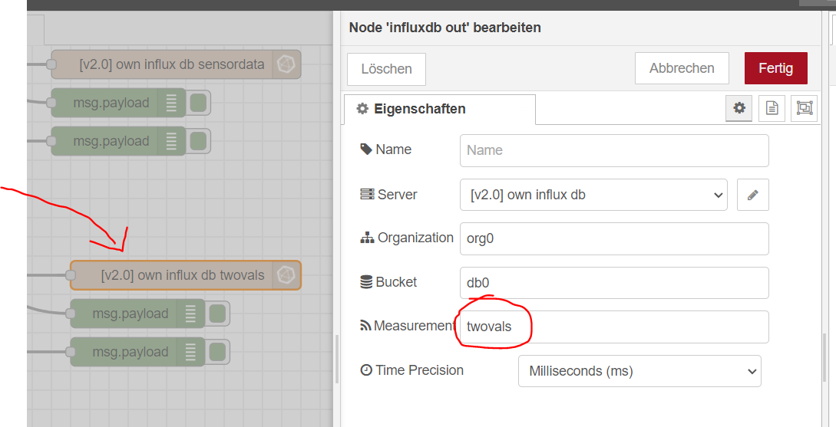

Please leave organization and bucket at "org0" and "db0".

In this case "db0" is the database and a "Measurement" is a table with several columns ("_field "s).

_time is the timestamp (like consecutive id) at which a new entry arrives in the measurement.

_field is the "column" and

_value the corresponding value

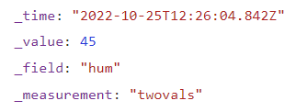

@Inlux:

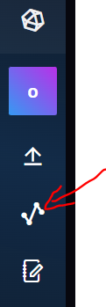

The query language is "Flux" ... and takes some getting used to.

The query builder in the Influx UI is puts the query together over a few clicks. A click on the button "Script Editor" displays the query:

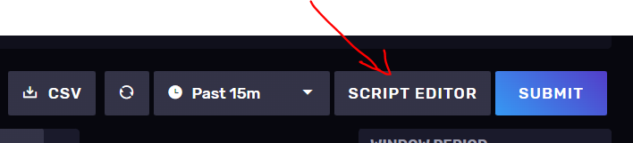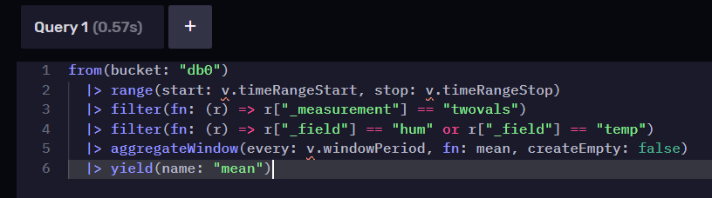

This can then be copied into Grafana.

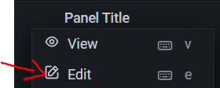

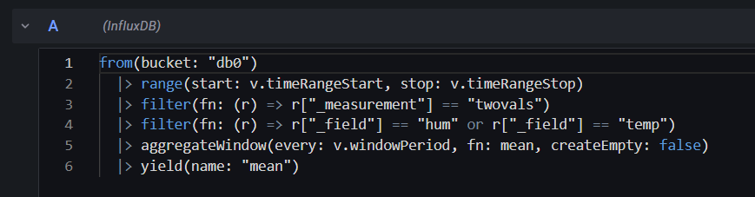

The timer range can be set in Grafana in the upper right corner:

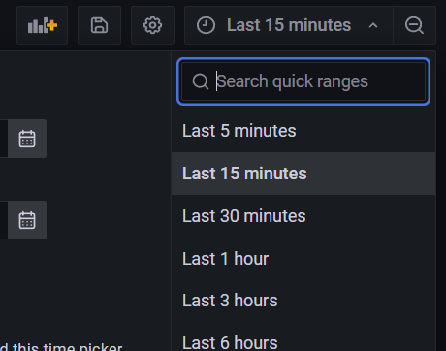

1. **Effort estimation**

Semester #4

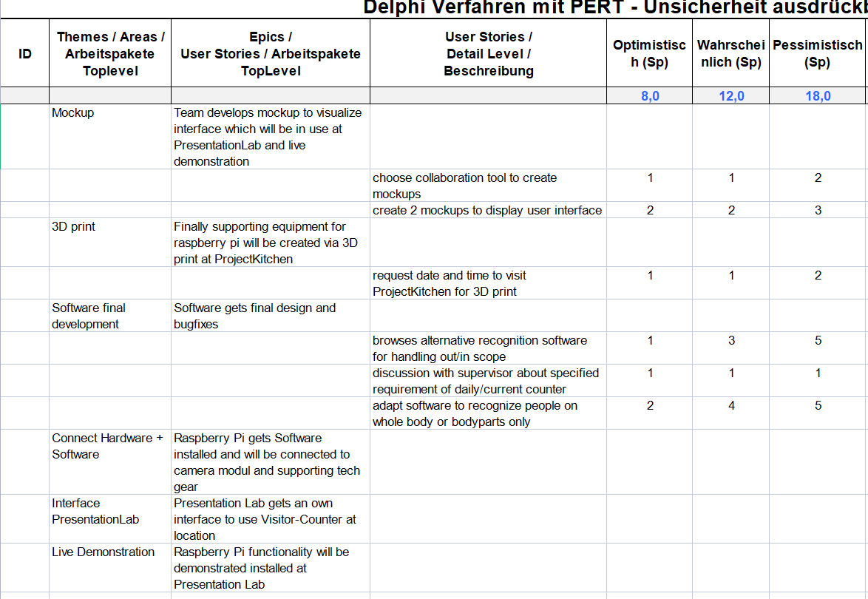

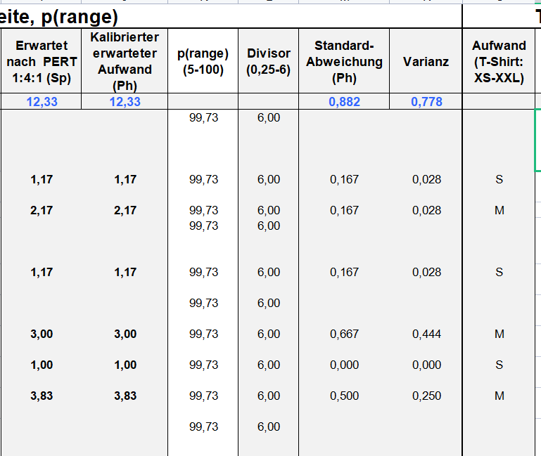

Semester #5

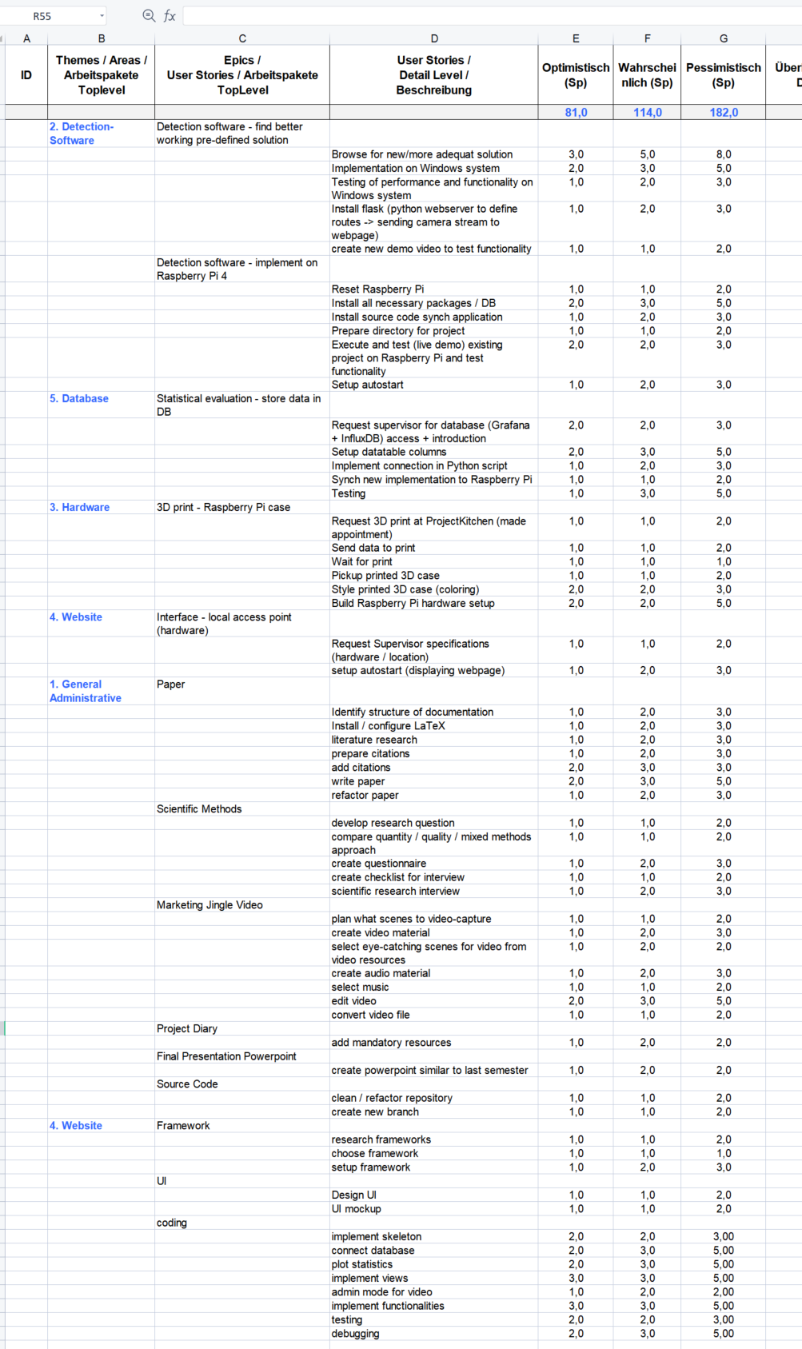

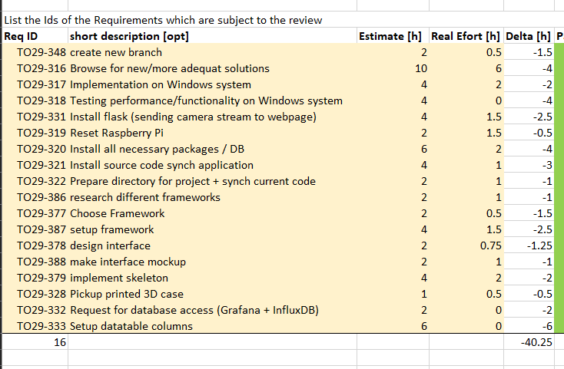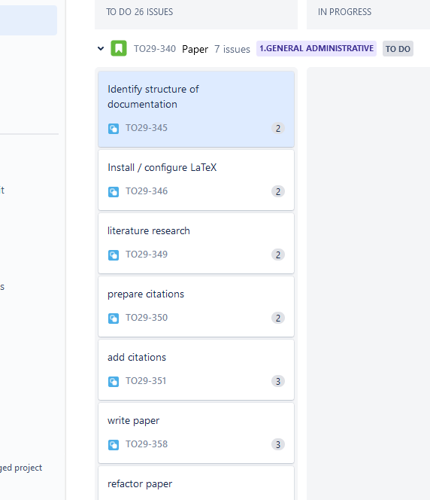



One Story point equals 2 hours of work, so we used it in every issue we had.

<https://github.com/unravelet/theObserver/blob/main/doc/Effort_Estimation/DAGoPERT_2016_slim.xlsx> [link to GitHub repository => excel sheet of effort estimation DAGoPERT]